1. **National Webinar on ‘Culture & Language’:** National Webinar on Culture & Language jointly **organised by Govt. Aizawl West College, Mizoram and Magadh University, Bihar** was held on **29th September, 2020** wherein resource persons from the organizing institutes reflected on the history, culture, tradition, language and communication of their respective states. The speakers also highlighted the **important role of culture and language in integrating the Indian subcontinent**.

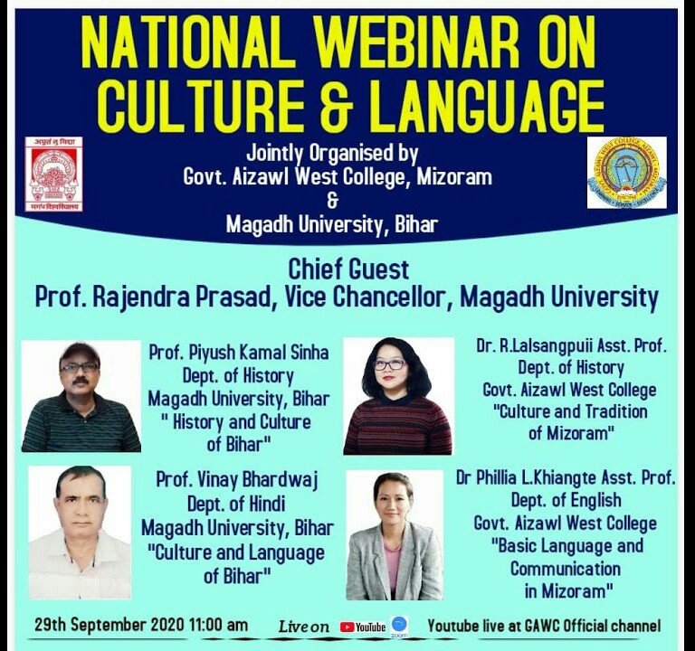

2. **National Education Day: Special Talk on ‘Relevance of Mother Tongue for Effective Learning’ – The programme was held on 11th November, 2021 and** Prof. Lalbiakdiki Hnamte, Director, College Development Council, Mizoram University stressed on the importance of one’s mother tongue to draw out the best for effective learning. She further **urged that one’s mother tongue is the means to the end product of a better understanding of phenomenon**.

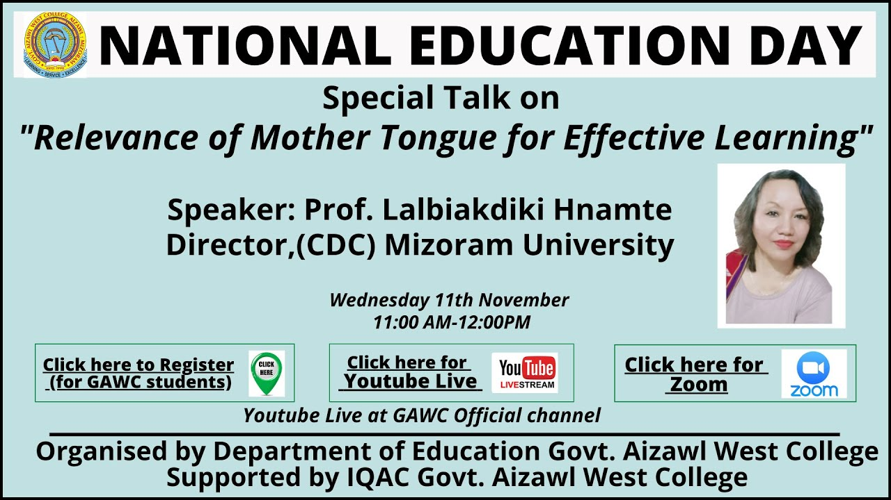

3. **West IMPRESS Series: Rekindling Normalcy IV – The fourth and final West Impress 2022 was held on 13th October 2020.** Mr. **Robert Lalchungnunga Chongthu, IAS, Divisional Commissioner, Saran, Bihar** was the resource person for the event. Drawing inferences from his experience, he drew light on the **importance of planning, communication skills as well as a balanced and diversified life to survive** in life, especially in the post Covid-19 world.

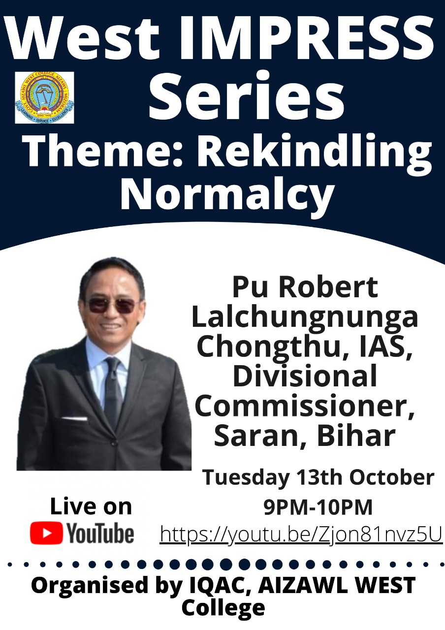

4. **Finishing School**

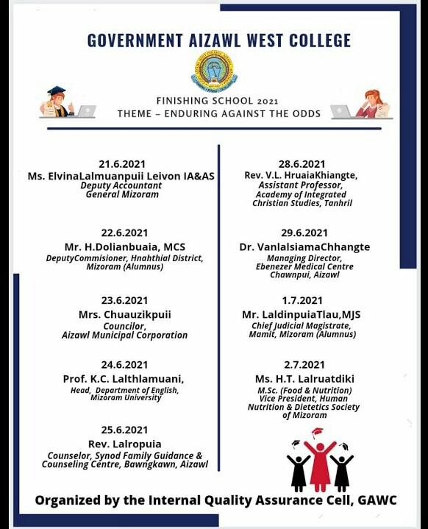

5. **Special Talk on Himna leh Phurna**

