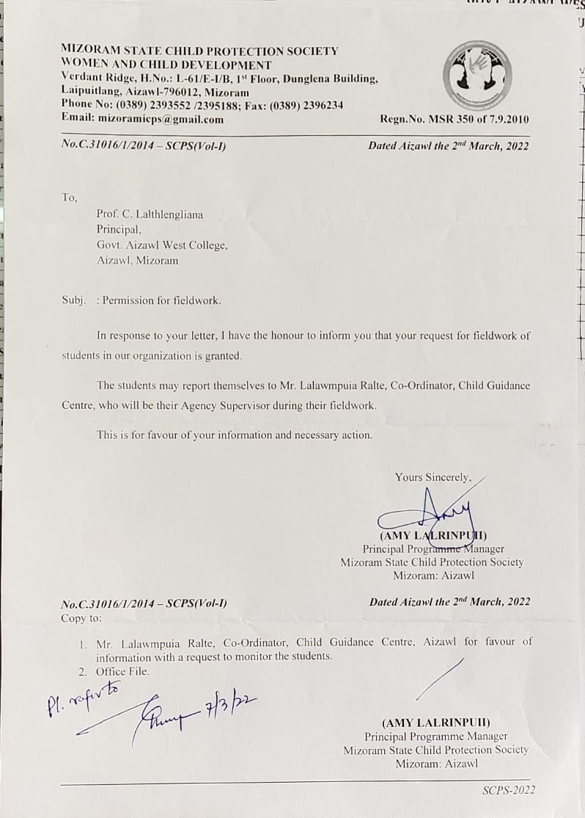

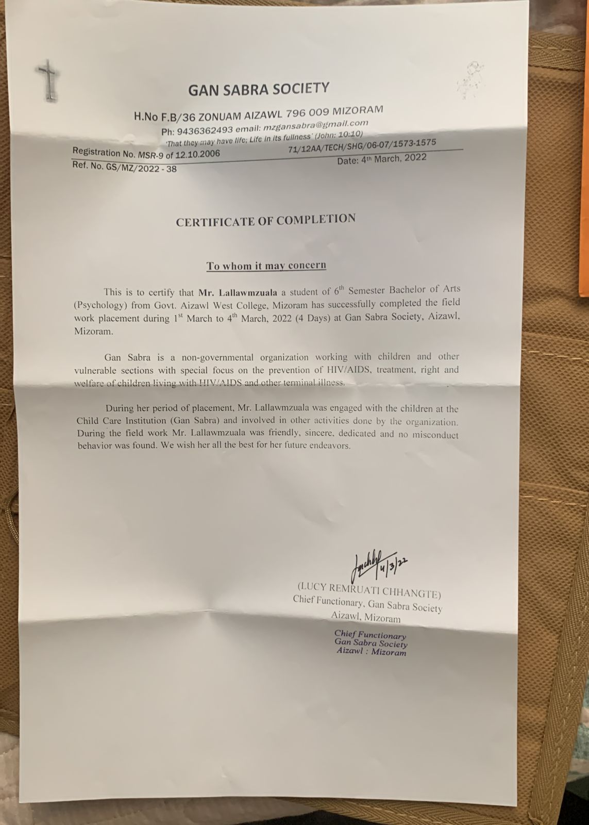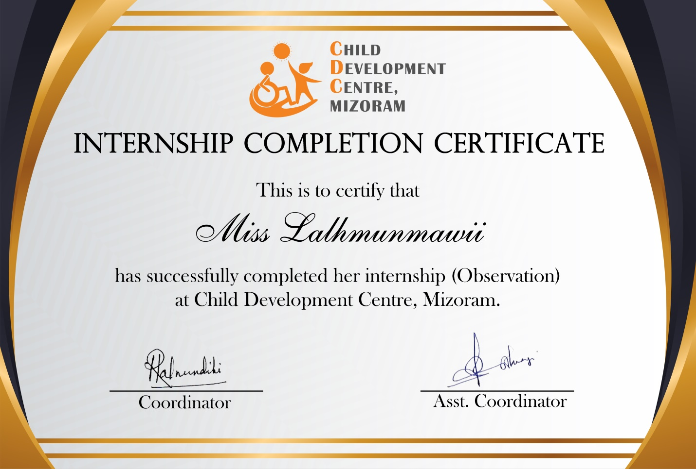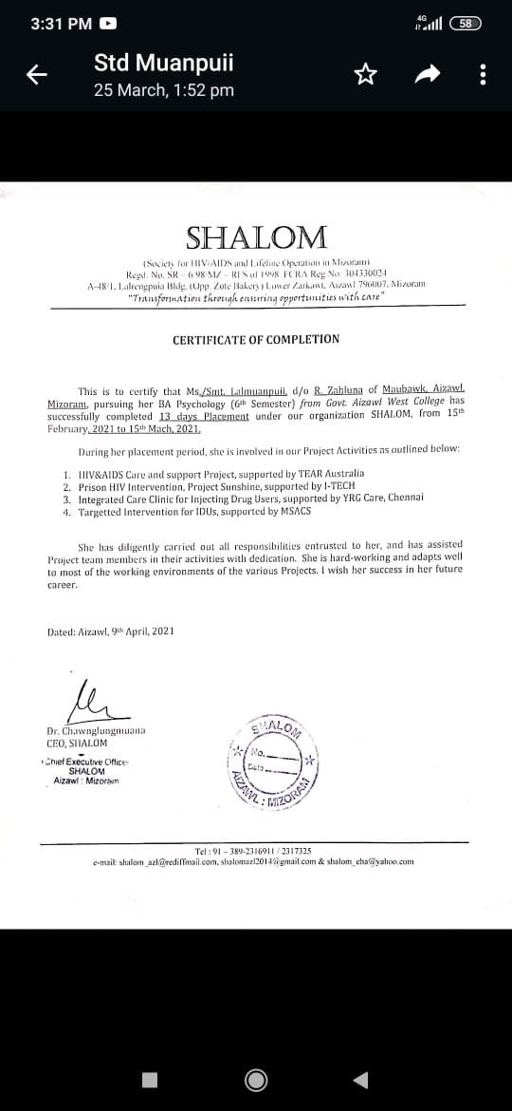

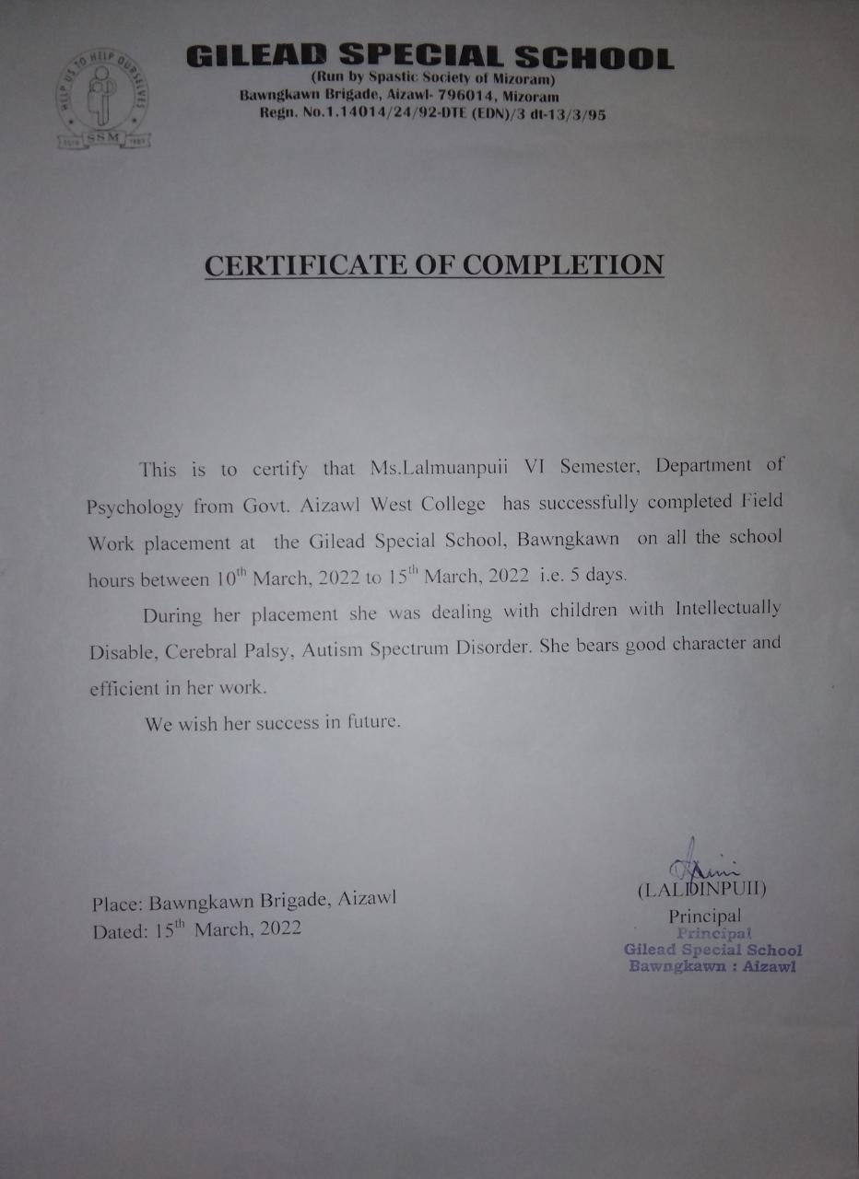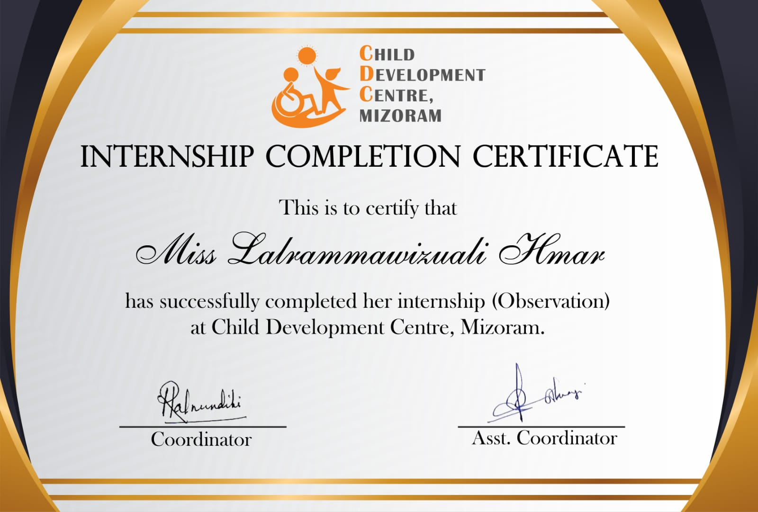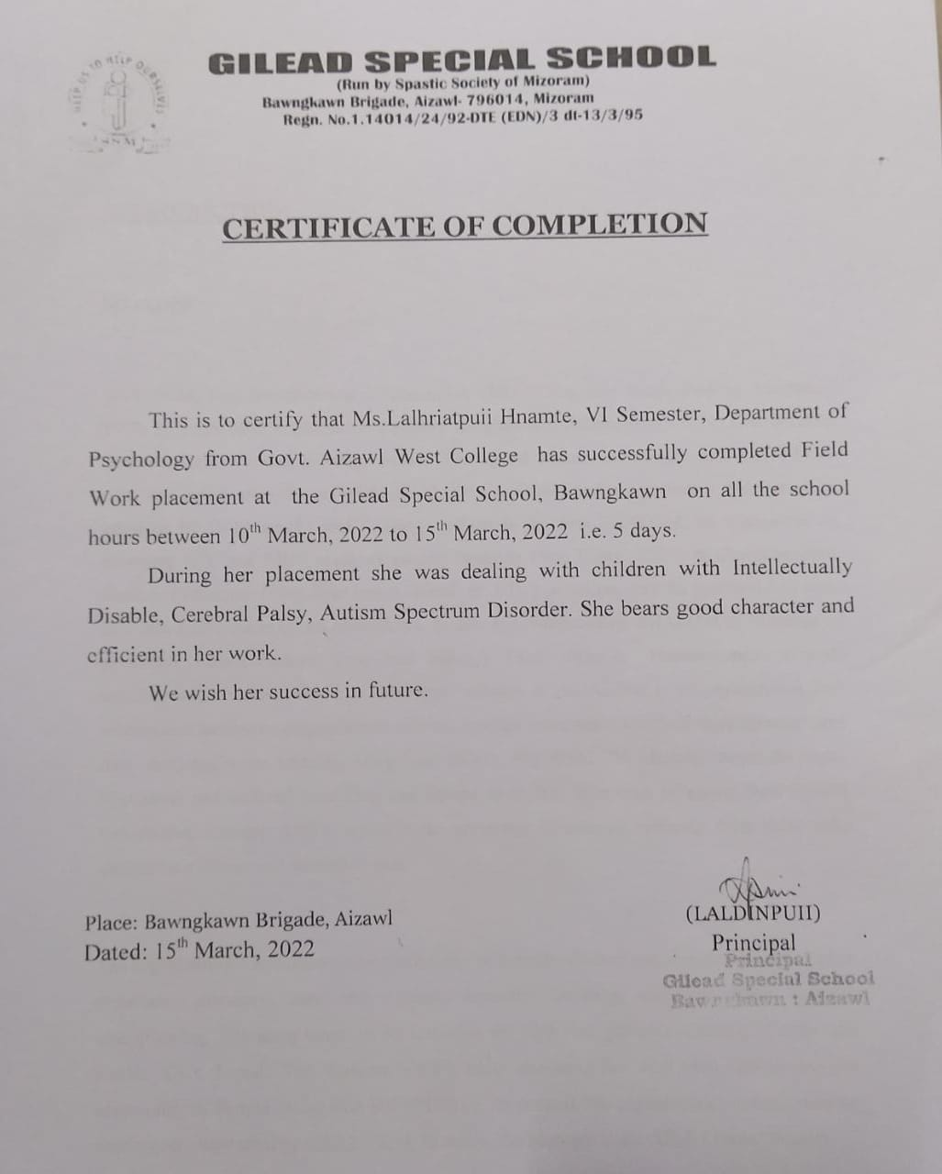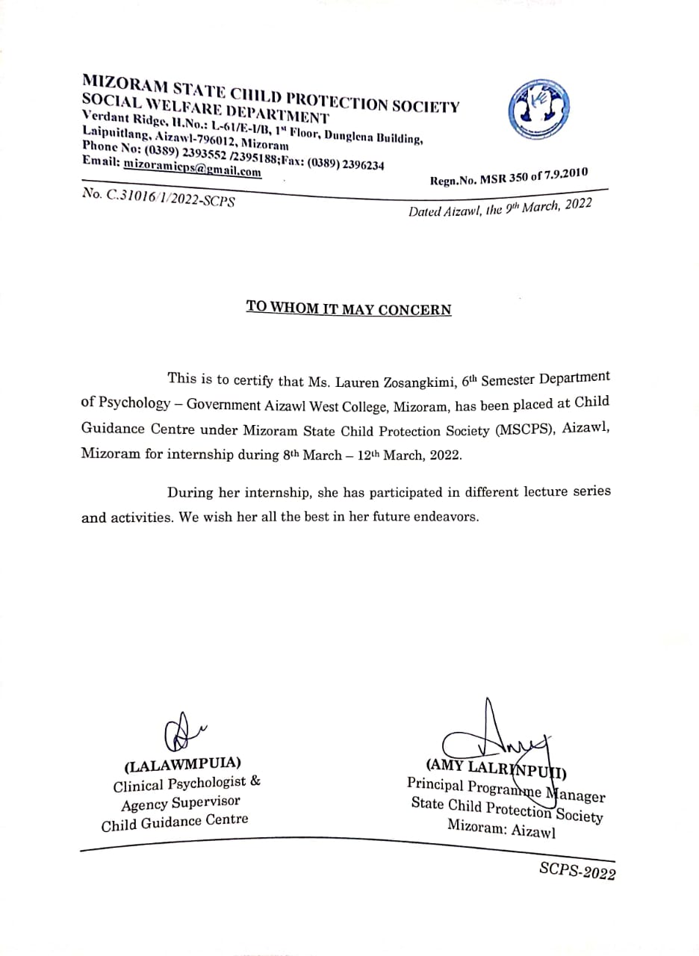

**1.3.2** - Psychology 5th Semester: Project (PSY/V/CC/10)

|  |  |  |  |
| --- | --- | --- | --- |
| **Sl. No.** | **Name** | **Topic** | **Scales** |
| 1 | Carmen Lalrindiki | Covid-19 impact on quality of life and level of hope among college students | COVID-19–Impact on Quality of Life (COV19-QoL) scale and hope scale |
| 2 | C Lalruattluangi | Perceived stress and life satisfaction among higher secondary students and college students | Perceived stress scale and satisfaction with life scale |
| 3 | Lalrintluangi | Effect of resilience on the level of perceived stress among college students | Brief resilience scale and PSS |
| 4 | Lalmuanpuii | The relationship between well being and resilience among higher secondary students and college students | WHO well being and BRS |
| 5 | Lalhmunmawii | To study corona virus related anxiety among parents | Coronavirus anxiety scale |
| 6 | Lalhriatpuii | The relationship between well being and self esteem among higher secondary students and college students | WEMWBS and Rosenberg Self esteem scale |
| 7 | Lalvenhima | To study academic motivation among college students and university students | Academic Motivation Scale (Ams-C 28)  College Version |
| 8 | Lawmzuala | To study gender differences in coping strategies among College and University students | Brief -COPE |
| 9 | RebekLalhmangaihsangi | Depression, anxiety and stress among Working mothers and Non-working mothers | DASS-21 |
| 10 | Zodinpuia | To study the level of HIV knowledge among college students and higher secondary students | HIV-kq 18 |
| 11 | Lalrammawizuali | To study the coping strategies of people living with chronic illnesses | Brief Resilient Coping Scale (BRCS) |
| 12 | Esther Lalramduhawmi | To study the relationship between coping styles and resilience among college students | Coping Strategies Inventory Short-Form  (*CSI-SF*) and Brief Resilience Scale |
| 13 | V.L Malsawmkimi | To study the relationship between personality traits and self esteem among college students | Big Five Inventory‐10 (BFI‐10) Rosenberg SESN |
| 14 | Lauren Zosangkimi | To study coping strategies of urban and rural college students | Brief-COPE |

