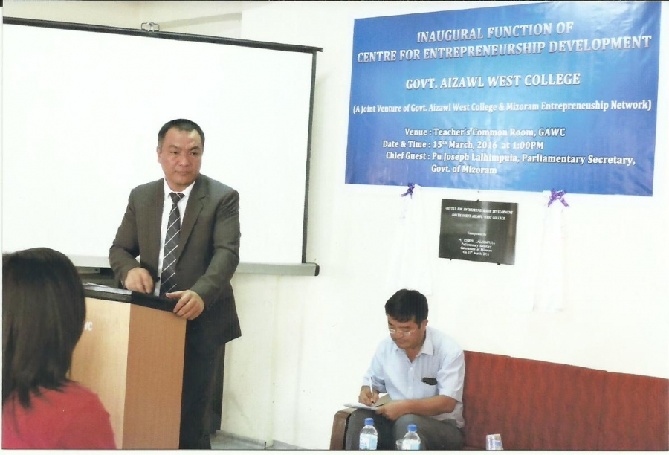

**INAUGURATION OF CENTRE FOR ENTERPRENEURSHIP DEVELOPMENT**

**Inaugurated by**

**Joseph Lalhlimpuia, Parliamentary Secretary ( 15.3.2016)**

**REPORT ON ENTREPRENEURSHIP DEVELOPMENT PROGRAMME**

**Under DAY-NULM**

**Conducted by**

**Centre for Entrepreneurship Development, Govt.Aizawl West College**

**Date : 7th -9th August,2019**

**Venue : DUDOs Conference Hall, Serchhip**

**District : Serchhip**

1.Number of Resource Person : Three (3) - Lalchhanhima, *Mr.Lalhmachhuana*, Miss Lalrofeli, MSACS representative, Bank Representative, Manager, NULM and successful Entrepreneur (Local)

2.Number of beneficiaries: 60 ( sixty)

3.Number of sessions /lectures : 4 (four) sessions per day including inaugural function and distribution of certificate.

**Topic of Lectures**

**DAY ONE**

1.10:00 - 11:00AM : Inauguration and introduction of the programme

2.11:00 – 12:00AM : Self-Employment Programme Under NULM

3.12:45 – 1:45PM : Basic of Entrepreneurship and Who is Entrepreneur?

4.1:45 - 2:45PM : Business Opportunity identification and Formalities for setting up Micro-Units.

**DAY TWO**

1.10:00 - 11:00AM : Awareness session on HIV/AIDS

2.11:00 – 12:00AM : Basic Soft Skills for successful Entrepreneurs

3.12:45 – 1:45PM : Basic of Market Survey and Detail Project Report

4.1:45 - 2:45PM : Basic of Book Keeping and Importance of Accounting

**DAY THREE**

1.10:00 - 11:00AM : Basic of Costing and Pricing and Working Capital

2.11:00 – 12:00AM : Interactions with successful entrepreneurs

3.12:45 – 1:45PM : Programme Evaluation and Feedback from trainees

4.1:45 - 2:45PM : Distribution of Certificate

**REPORT ON ENTREPRENEURSHIP DEVELOPMENT PROGRAMME**

**Under DAY-NULM**

**Conducted by**

**Centre for Entrepreneurship Development, Govt.Aizawl West College**

**Date : 20th-22nd August,2019**

**Venue : UD &PA Conference hall, Kolasib**

**District : Kolasib**

1.Number of Resource Person : Three (3) – Lalchhanhima, *Mr.Vanenga*, Dr.R.Lalsangpuii MSACS representative, Bank Representative, Manager, NULM and successful Entrepreneur (Local)

2.Number of beneficiaries: 60 ( sixty)

3.Number of sessions /lectures : 4 (four) sessions per day including inaugural function and distribution of certificate.

**Topic of Lectures**

**DAY ONE**

1.10:00 - 11:00AM : Inauguration and introduction of the programme

2.11:00 – 12:00AM : Self-Employment Programme Under NULM

3.12:45 – 1:45PM : Basic of Entrepreneurship and Who is Entrepreneur?

4.1:45 - 2:45PM : Business Opportunity identification and Formalities for setting up Micro-Units.

**DAY TWO**

1.10:00 - 11:00AM : Awareness session on HIV/AIDS

2.11:00 – 12:00AM : Basic Soft Skills for successful Entrepreneurs

3.12:45 – 1:45PM : Basic of Market Survey and Detail Project Report

4.1:45 - 2:45PM : Basic of Book Keeping and Importance of Accounting

**DAY THREE**

1.10:00 - 11:00AM : Basic of Costing and Pricing and Working Capital

2.11:00 – 12:00AM : Interactions with successful entrepreneurs

3.12:45 – 1:45PM : Programme Evaluation and Feedback from trainees

4.1:45 - 2:45PM : Distribution of Certificate

**REPORT ON ENTREPRENEURSHIP DEVELOPMENT PROGRAMME**

**Under DAY-NULM**

**Conducted by**

**Centre for Entrepreneurship Development, Govt.Aizawl West College**

**Date : 27th-29th August, 2019**

**Venue : I &PR Hall, Siaha**

**District : Siaha**

1.Number of Resource Person : Three (3) – Dr.H.S.Lalbiakengi, Miss *Lalhlimpuii,* Mr.V.Zothankhuma, MSACS representative, Bank Representative, Manager, NULM and successful Entrepreneur (Local)

2.Number of beneficiaries: 60 ( sixty)

3.Number of sessions /lectures : 4 (four) sessions per day including inaugural function and distribution of certificate.

**Topic of Lectures**

**DAY ONE**

1.10:00 - 11:00AM : Inauguration and introduction of the programme

2.11:00 – 12:00AM : Self-Employment Programme Under NULM

3.12:45 – 1:45PM : Basic of Entrepreneurship and Who is Entrepreneur?

4.1:45 - 2:45PM : Business Opportunity identification and Formalities for setting up Micro-Units.

**DAY TWO**

1.10:00 - 11:00AM : Awareness session on HIV/AIDS

2.11:00 – 12:00AM : Basic Soft Skills for successful Entrepreneurs

3.12:45 – 1:45PM : Basic of Market Survey and Detail Project Report

4.1:45 - 2:45PM : Basic of Book Keeping and Importance of Accounting

**DAY THREE**

1.10:00 - 11:00AM : Basic of Costing and Pricing and Working Capital

2.11:00 – 12:00AM : Interactions with successful entrepreneurs

3.12:45 – 1:45PM : Programme Evaluation and Feedback from trainees

4.1:45 - 2:45PM : Distribution of Certificate

**REPORT ON ENTREPRENEURSHIP DEVELOPMENT PROGRAMME Under DAY-NULM**

**Conducted by**

**Centre for Entrepreneurship Development, Govt.Aizawl West College**

**Date : 30th August-3rd September, 2019**

**Venue : DROs Conference hall, Lawngtlai**

**District : Lawngtlai**

1.Number of Resource Person : Three (3) – Dr.H.S.Lalbiakengi, Mr.Lalthansanga,C, Mr.T.Lalrinmawia, MSACS representative, Bank Representative, Manager, NULM and successful Entrepreneur (Local)

2.Number of beneficiaries: 60 ( sixty)

3.Number of sessions /lectures : 4 (four) sessions per day including inaugural function and distribution of certificate.

**Topic of Lectures**

**DAY ONE**

1.10:00 - 11:00AM : Inauguration and introduction of the programme

2.11:00 – 12:00AM : Self-Employment Programme Under NULM

3.12:45 – 1:45PM : Basic of Entrepreneurship and Who is Entrepreneur?

4.1:45 - 2:45PM : Business Opportunity identification and Formalities for setting up Micro-Units.

**DAY TWO**

1.10:00 - 11:00AM : Awareness session on HIV/AIDS

2.11:00 – 12:00AM : Basic Soft Skills for successful Entrepreneurs

3.12:45 – 1:45PM : Basic of Market Survey and Detail Project Report

4.1:45 - 2:45PM : Basic of Book Keeping and Importance of Accounting

**DAY THREE**

1.10:00 - 11:00AM : Basic of Costing and Pricing and Working Capital

2.11:00 – 12:00AM : Interactions with successful entrepreneurs

3.12:45 – 1:45PM : Programme Evaluation and Feedback from trainees

4.1:45 - 2:45PM : Distribution of Certifcate

**REPORT ON ENTREPRENEURSHIP DEVELOPMENT PROGRAMME**

**Under DAY-NULM**

**Conducted by**

**Centre for Entrepreneurship Development, Govt.Aizawl West College**

**Date : 4th -6th September,2019**

**Venue : Y.M.a.Conference Hall, Lunglei District : Lunglei**

1.Number of Resource Person : Three (3) – Mr.V.Zothankhuma, Dr.R.Lalsangpuii Dr.Benjamin Lalrinsanga, MSACS representative, Bank Representative, Manager, NULM and successful Entrepreneur (Local)

2.Number of beneficiaries: 60 ( sixty)

3.Number of sessions /lectures : 4 (four) sessions per day including inaugural function and distribution of certificate.

**Topic of Lectures**

**DAY ONE**

1.10:00 - 11:00AM : Inauguration and introduction of the programme

2.11:00 – 12:00AM : Self-Employment Programme Under NULM

3.12:45 – 1:45PM : Basic of Entrepreneurship and Who is Entrepreneur?

4.1:45 - 2:45PM : Business Opportunity identification and Formalities for setting up Micro-Units.

**DAY TWO**

1.10:00 - 11:00AM : Awareness session on HIV/AIDS

2.11:00 – 12:00AM : Basic Soft Skills for successful Entrepreneurs

3.12:45 – 1:45PM : Basic of Market Survey and Detail Project Report

4.1:45 - 2:45PM : Basic of Book Keeping and Importance of Accounting

**DAY THREE**

1.10:00 - 11:00AM : Basic of Costing and Pricing and Working Capital

2.11:00 – 12:00AM : Interactions with successful entrepreneurs

3.12:45 – 1:45PM : Programme Evaluation and Feedback from trainees

4.1:45 - 2:45PM : Distribution of Certificate

**REPORT ON ENTREPRENEURSHIP DEVELOPMENT PROGRAMME**

**Under DAY-NULM**

**Conducted by**

**Centre for Entrepreneurship Development, Govt.Aizawl West College**

**Date : 11st-13rd September,2019**

**Venue :**

**District : Chmphai**

1.Number of Resource Person : Three (3) – Mr.Lalchhanhima, Dr.H.S.Lalbiakengi, Miss Lalrofeli, MSACS representative, Bank Representative, Manager, NULM and successful Entrepreneur (Local)

2.Number of beneficiaries: 60 ( sixty)

3.Number of sessions /lectures : 4 (four) sessions per day including inaugural function and distribution of certificate.

**Topic of Lectures**

**DAY ONE**

1.10:00 - 11:00AM : Inauguration and introduction of the programme

2.11:00 – 12:00AM : Self-Employment Programme Under NULM

3.12:45 – 1:45PM : Basic of Entrepreneurship and Who is Entrepreneur?

4.1:45 - 2:45PM : Business Opportunity identification and Formalities for setting up Micro-Units.

**DAY TWO**

1.10:00 - 11:00AM : Awareness session on HIV/AIDS

2.11:00 – 12:00AM : Basic Soft Skills for successful Entrepreneurs

3.12:45 – 1:45PM : Basic of Market Survey and Detail Project Report

4.1:45 - 2:45PM : Basic of Book Keeping and Importance of Accounting

**DAY THREE**

1.10:00 - 11:00AM : Basic of Costing and Pricing and Working Capital

2.11:00 – 12:00AM : Interactions with successful entrepreneurs

3.12:45 – 1:45PM : Programme Evaluation and Feedback from trainees

4.1:45 - 2:45PM : Distribution of Certificate

**REPORT ON ENTREPRENEURSHIP DEVELOPMENT PROGRAMME**

**Under DAY-NULM**

**Conducted by**

**Centre for Entrepreneurship Development, Govt.Aizawl West College**

**Date : 17th-19th September,2019**

**Venue : LAD Conference Hall, Mamit**

**District : Mamit**

1.Number of Resource Person : Three (3) – Dr.Benjamin Lalrinsanga, Mr.Lalrinpuia, Mr.V.Zothankhuma, MSACS representative, Bank Representative, Manager, NULM and successful Entrepreneur (Local)

2.Number of beneficiaries: 60 ( sixty)

3.Number of sessions /lectures : 4 (four) sessions per day including inaugural function and distribution of certificate.

**Topic of Lectures**

**DAY ONE**

1.10:00 - 11:00AM : Inauguration and introduction of the programme

2.11:00 – 12:00AM : Self-Employment Programme Under NULM

3.12:45 – 1:45PM : Basic of Entrepreneurship and Who is Entrepreneur?

4.1:45 - 2:45PM : Business Opportunity identification and Formalities for setting up Micro-Units.

**DAY TWO**

1.10:00 - 11:00AM : Awareness session on HIV/AIDS

2.11:00 – 12:00AM : Basic Soft Skills for successful Entrepreneurs

3.12:45 – 1:45PM : Basic of Market Survey and Detail Project Report

4.1:45 - 2:45PM : Basic of Book Keeping and Importance of Accounting

**DAY THREE**

1.10:00 - 11:00AM : Basic of Costing and Pricing and Working Capital

2.11:00 – 12:00AM : Interactions with successful entrepreneurs

3.12:45 – 1:45PM : Programme Evaluation and Feedback from trainees

4.1:45 - 2:45PM : Distribution of Certificate